1. First take a backup of your assignments & projects. This is required because due to incorrect GIT operation you may lose your files.

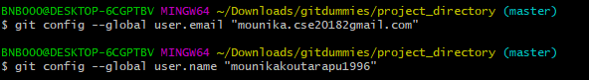

1. Create an empty directory ‘Assignments’ & cd to ‘Assignments’

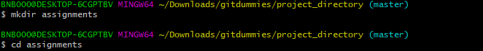

1. Create a file README.txt inside ‘Assignments’ & write few lines about the contents of ‘Assignments’ folder.

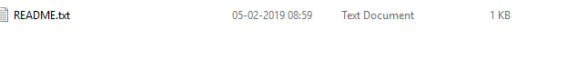

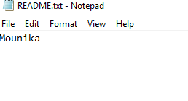

1. Commit README.txt file.

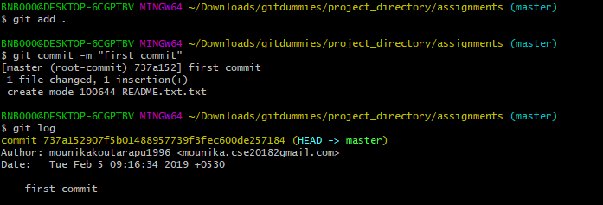

1. Now create a new branch ‘html-assignments’

C:\Users\BNB000\Downloads\html\git ass 2\as 5.PNG

1. Switch to ‘html-assignments’ branch.

C:\Users\BNB000\Downloads\html\git ass 2\as 6.PNG

1. Copy all HTML assignments inside ‘Assignments’ folder.

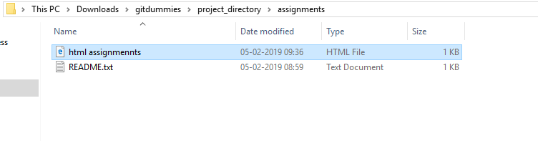

1. Commit HTML assignments into ‘html-assignments’ branch.

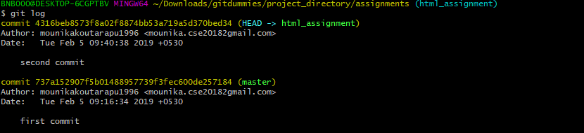

1. Make minor changes into few files belonging to ‘html-assignments’ branch.

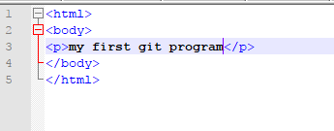

1. Commit those changed files.

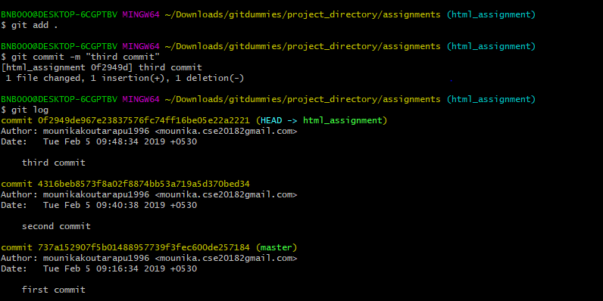

1. Switch to master branch.



1. Make minor changes into README.txt file & commit those changes into master.

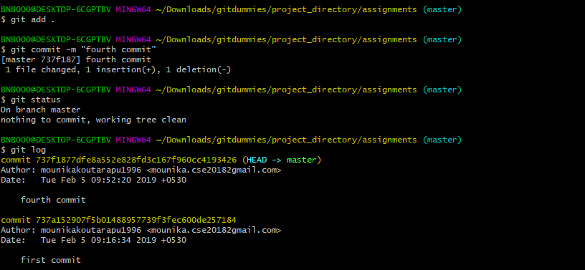

13 . Again switch to ‘html-assignments’ branch.



14 . Make minor changes into few files belonging to ‘html-assignments’ branch.

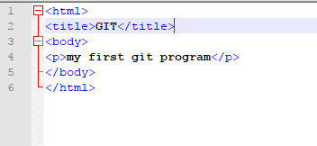

15. Commit those changes

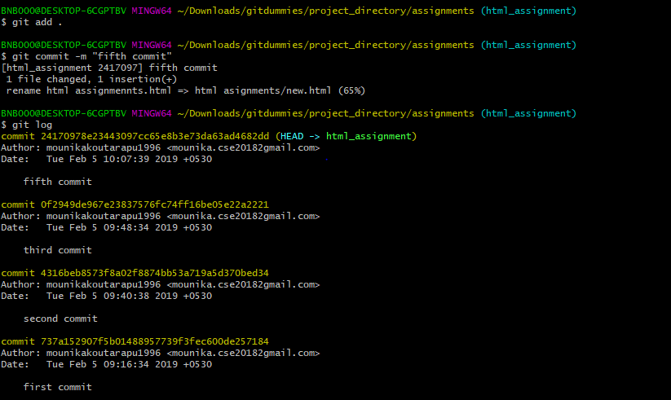

16. Switch to master.

17. Merge ‘html-assignments’ branch into master. Confirm all html assignments are shown in master.

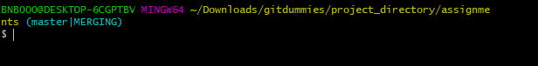

18.Finally delete the ‘html-assignments’ branch.



Section-2

1. Create a new branch ‘css-assignments’.

C:\Users\BNB000\Downloads\html\git ass 2\css1.PNG

1. Switch to ‘css-assignments’ branch.



1. Copy all CSS assignments inside ‘Assignments’ folder.

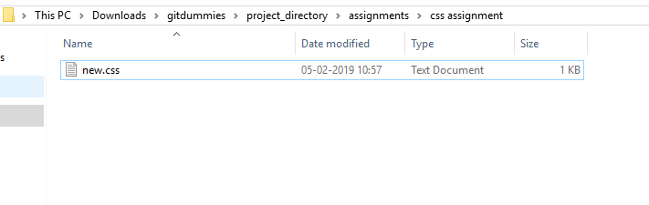

1. Commit CSS assignments into ‘css-assignments’ branch.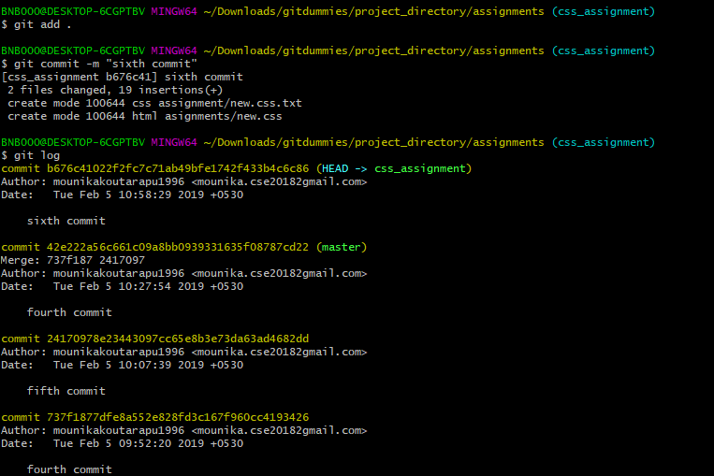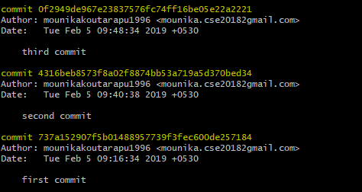
2. Make minor changes into README.txt file on line 1 belonging to ‘css-assignments’ branch.

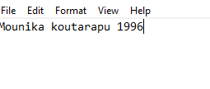

1. Commit those changed files.

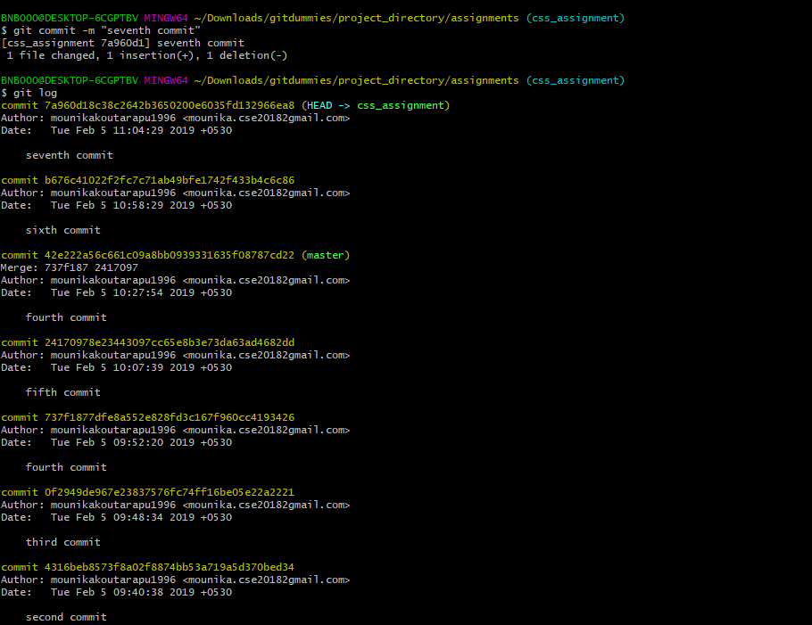

1. Switch to master branch.



1. Make minor changes into README.txt file on line 3 & commit those changes into master.

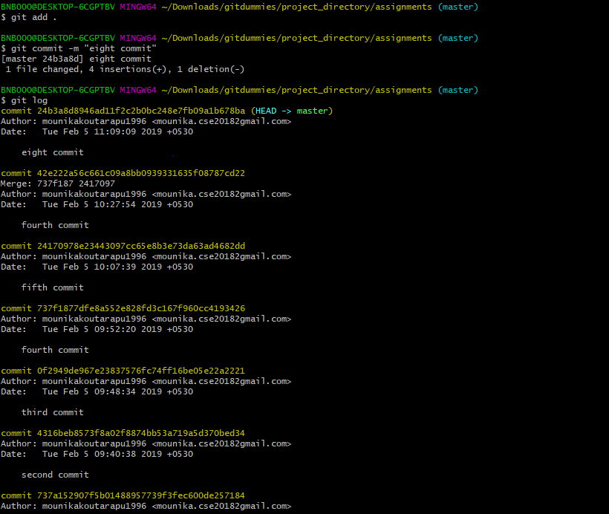

1. Again switch to ‘css-assignments’ branch.

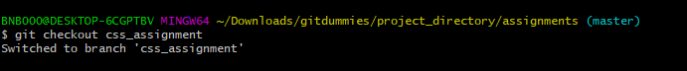

1. Make minor changes into few files belonging to ‘css-assignments’ branch.

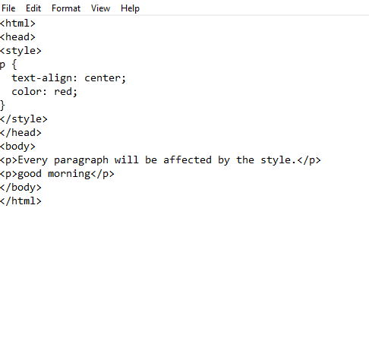

1. .Commit those changes.

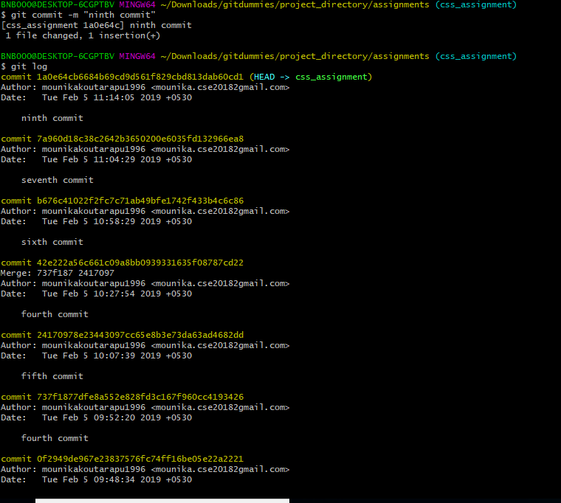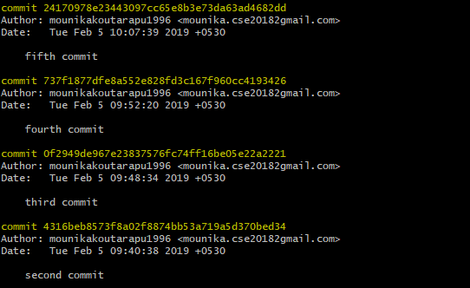

12 . Switch to master.



1. Merge ‘css-assignments’ branch into master. Confirm all css assignments are shown in master.

Section 3

1. Create a new branch ‘js-assignments’.



1. Switch to ‘js-assignments’ branch

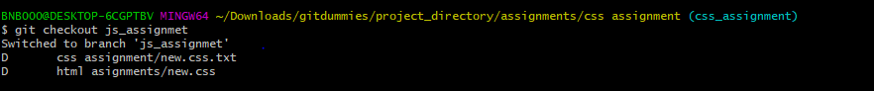

1. Copy all JavaScript assignments inside ‘Assignments’ folder.

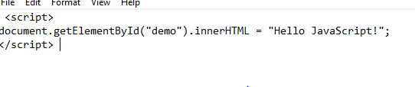

1. Commit JavaScript assignments into ‘js-assignments’ branch.

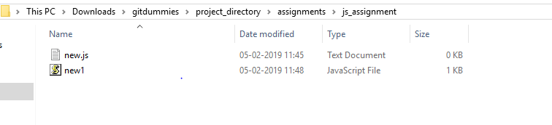

1. Make minor changes into README.txt file on line 1 belonging to ‘js-assignments’ branch.

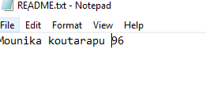

1. Commit those changed files.

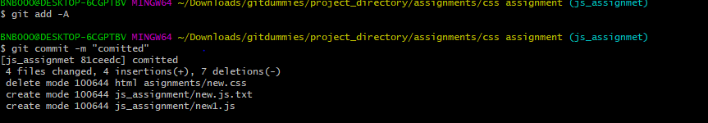

1. Switch to master branch.

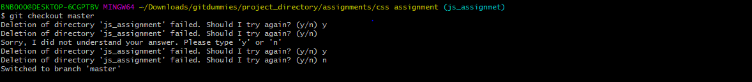

1. Make minor changes into README.txt file on line 1 & commit those changes into master.

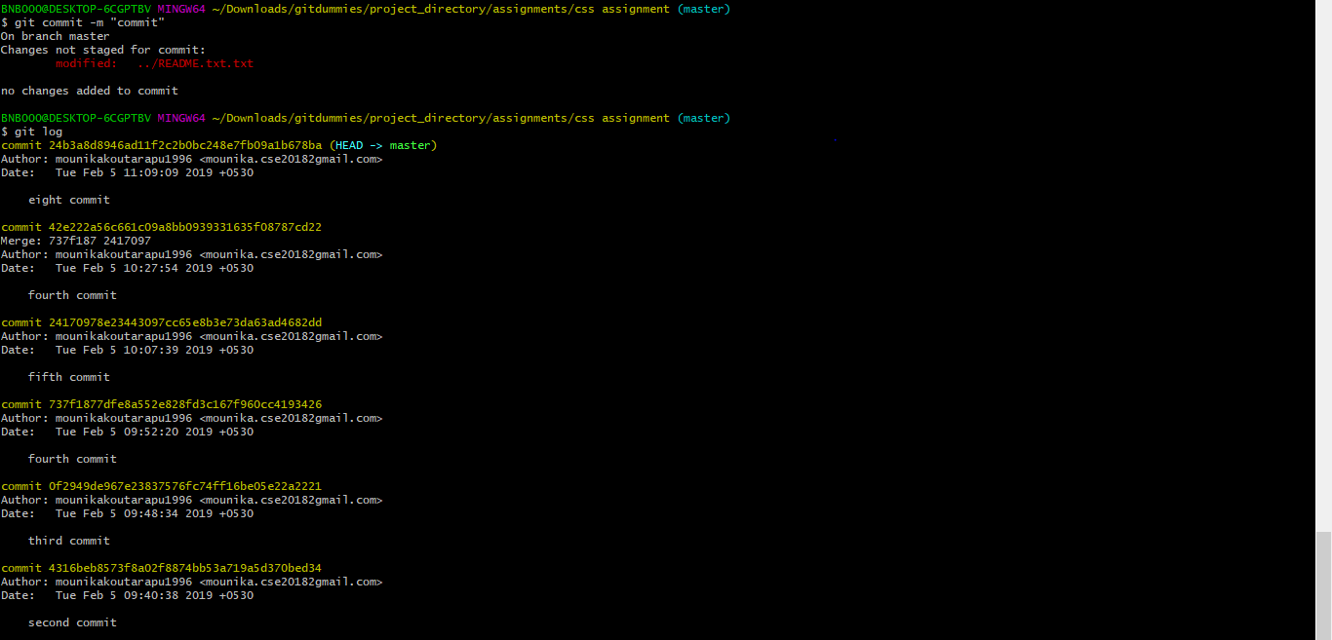

1. Again switch to ‘js-assignments’ branch.



1. Make minor changes into few files belonging to ‘js-assignments’ branch.

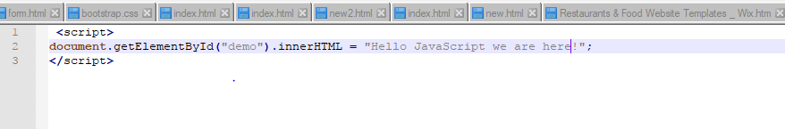

1. Commit those changes.

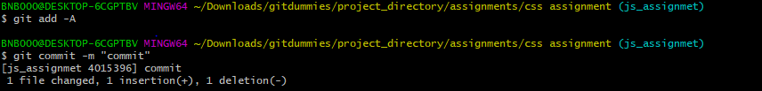

1. Switch to master.



1. Merge ‘js-assignments’ branch into master. Confirm all JavaScript assignments are shown in master.

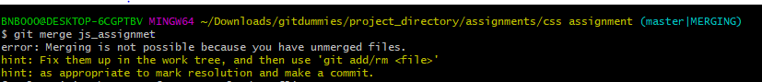

1. Finally delete the ‘js-assignments’ branch.

